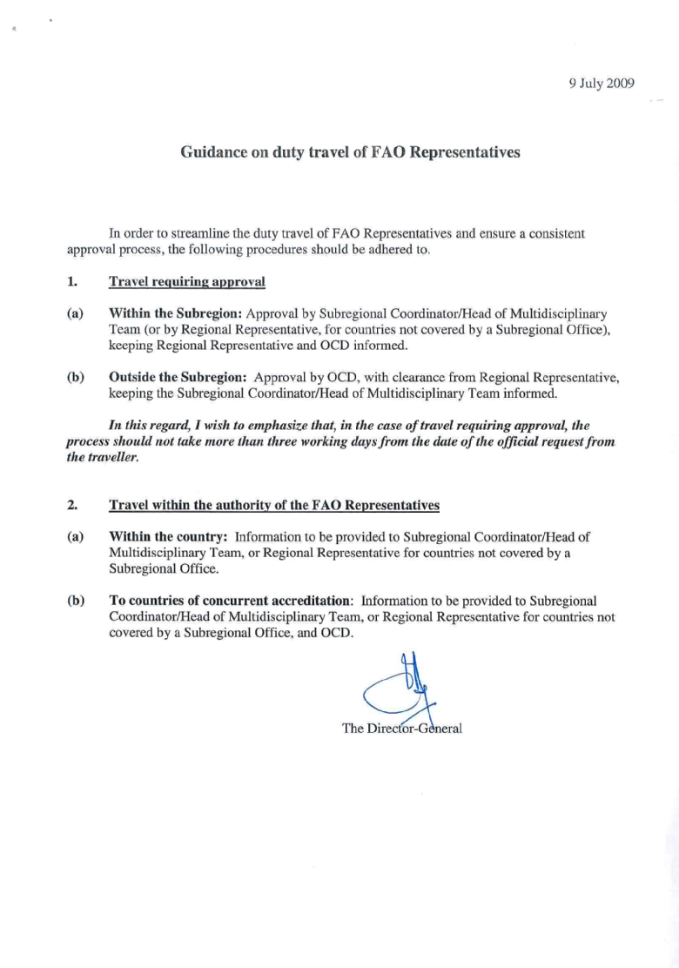

(for additional guidance on international travel of NPOs, please see the page on National Professional Officers)

From: Ali, Basharat (OCDD)
Sent: 05 October 2007 15:32
To: DL-DO-All-List
Cc: Deputy-Director-General (ODG); Directeur-de-Cabinet (ODG); DL-ADGs-HQ-List; DL-Directors-List; Thomas, Laurent (OCDO); Ali, Basharat (OCDD); Khan, Daud (OCDC); Gilmozzi, Dario (OCDO); Lehel, Janos (OCDO); Klompenhouwer, Yves (OCDC); Borelli, Simone (OCDO); Mol, Victor (OCDO); Marchetti, Ugo (OCDO); Boualam, Bakhta (OCDO); Drissi, Siham (OCDO); Ring, Sieglinde (OCDC); Epifania, Patrizia (OCDO); OCD-Registry
Subject: Delegation of Authority for Approval of Travel and Leave Plans for RRs, DRRs, Directors of LOs, SRR/SRCs, FAORs and A-FAORs

Follow Up Flag: Follow up
Due By: 04 October 2007 00:00
Flag Status: Completed
Dear Colleagues,

In line with the Director-General’s policy of entrusting increased authority to decentralized offices for all relevant aspects of the Organization’s activities, I am pleased to provide below the delegation of authority for the approval of

• Official Travel
• Leave Plans
for Regional Representatives and their Deputies, Directors of Liaison Offices, Subregional Representatives/Coordinators, FAO Representatives, and Assistant FAO Representatives.

The attached Table (Annex 1) presents a summary of the delegation of authority for approval for each category of officials and type of travel. The table will also be made available in COIN. Below is a description of the delegation of authority which is summarized in the table.

1. OFFICIAL TRAVEL

1.1 Regional Offices:

Regional Representatives: by the Director-General, through OCD.

Deputy Regional Representatives
• within the region: by the Regional Representative, keeping ODG and OCD informed;
• outside the region: by the Director-General, through OCD, upon request by the Regional Representative.

1.2 Subregional Offices:

Subregional Representatives/Coordinators
• within the subregion: by the Regional Representative, keeping ODG and OCD informed;
• outside the subregion (for SRO/SRCs as well as FAORs):

(a) Training: Any request for participation in training should be initiated and/or approved by the Director, OCD, taking into account (i) the FAOR network biennial training plan prepared by OCD in cooperation with AFH; (ii) the need for each FAOR concerned for such a training; (iii) the FAORs’ relative seniority and experience for the training programme to be relevant and useful; (iv) patterns of the proposed staff member’s travel over the past biennium; and (v) if the training programme is on a global or regional level, to ensure a reasonable regional or subregional representation. While ODG approval would not be specifically sought, except in cases where the Director, OCD, feels it is warranted, ODG would be kept informed.

(b) Technical meetings: The inviting technical unit should submit to the Director, OCD, a proposal for the FAOR/SRC/SRR attendance with rationale and justification, including the expected contribution of the FAOR/SRC/SRR to the meeting, and the financing source, prior to undertaking any direct consultations with the FAOR/SRC/SRR. Based on OCD’s review of the merit of the proposal, a submission is to be made by OCD to ODG for approval.

(c) Consultations/Seminars organized on specific topics/themes (e.g. One UN Pilots): Generally, consultations and seminars of this type, held at headquarters or at a decentralized location, have a major impact on the level of information, knowledge and capacity of the FAOR/SRC/SRR concerned, and could serve – to a large extent – as training fora. Apart from judging the concerned FAOR/SRC/SRR’s relevance and involvement with the topic/theme, the criteria indicated under “Training” could be used, as applicable, in this case. Then, in consultation with, and agreement of, the technical department concerned, OCD would make a submission to ODG for approval.

(d) External meetings and events: For the proposed participation of FAORs/SRCs/SRRs in external meetings, the existing procedure of docket circulation, culminating in ODG approval, should continue to apply under the following lead units’ responsibility: KCC for inter-governmental meetings; UNC for UN system meetings; ODGS for meetings organized by non-governmental organizations; TC for meetings organized by governments and funding institutions, as well as meetings concerning emergencies and humanitarian assistance; and NR for meetings organized by the CGIAR and international research centres.

1.3 FAO Representations:

FAO Representatives
• within the subregion: by the Subregional Representative/Coordinator, keeping the RR and OCD informed. Travel within the Subregion for FAORs not covered by a Subregional Office is approved by the RR, keeping OCD informed.
• outside the subregion: same as above (point 1.2) for SRCs/SRRs.

Assistant FAO Representatives
• within the subregion: by the Subregional Representative/Coordinator, upon request by the FAOR, keeping the RR and OCD informed. For A-FAORs not covered by a Subregional Office, the Regional Representative will approve travel within the subregion, upon request by the FAOR, keeping OCD informed.
• outside the subregion: same as above (point 1.2) for SRCs/SRRs and FAORs.

1.4 Liaison Offices:

Directors of Liaison Offices LOGE and LONY: by the Director-General, through UNC.

Directors of Liaison Offices LOWA, LOBR and LOJA: by the Director-General, through OCD.

2. LEAVE
(This includes annual leave, home leave, rest and recuperation, family emergency, uncertified sick leave, special leave and advance leave up to 10 days)

- Regional Representatives: by the Director, OCD, keeping ODG and Shared Services Centre (SSC) informed;
- Deputy Regional Representatives: by the Regional Representatives, keeping ODG, OCD and SSC informed;
- Subregional Representatives/Coordinators: by the Regional Representative, keeping ODG, OCD and SSC informed;
- FAO Representatives: by the Subregional Representative/Coordinator, keeping the Regional Representative, OCD and SSC informed; for FAO Representatives in countries not covered by a Subregional Office, the Regional Representative will approve annual leave of FAORs, keeping OCD and SSC informed;
- A-FAORs: by the FAO Representative, keeping OCD and SSC informed;
- Directors of Liaison Offices LOGE and LONY: by the Assistant Director-General UNC, keeping ODG and SSC informed;
- Directors of Liaison Offices LOWA, LOBR and LOJA: by the Director, OCD, keeping ODG and SSC informed.

The relevant Manual Sections will be amended accordingly in due course. Current arrangements for authorizing travel and leave for other decentralized personnel remain in effect until further notice. Offices responsible for approving of leave (UNC, OCD, ROs, SROs and FAORs) are requested to ensure that the competent SSC officer is copied for record keeping purposes.

I wish to remind FAO Representatives of the need to propose the name of the FAO Representative a.i. during their absence for OCD approval, once their travel or leave has been approved. Likewise, Regional Representatives, Subregional Coordinators/Representatives and Directors of Liaison Offices are to keep OCD or UNC, as appropriate, informed of the names of the Officer-in-Charge during their absence from the office.

Finally, I also wish to recall that OCD - at the beginning of the year - issues travel authorizations for FAO Representatives to travel to countries covered under multiple accreditation.

Regards,

Basharat ALI
Director, OCD

